**ENGLISH PREMIER LEAGUE MANAGEMENT SYSTEM**

**BY**

**YASH KHOPKAR**

**001850102**

**PURPOSE:**

I am creating a database to organize its fixtures more efficiently to attract more audience. Also to avoid fixture congestion and to help the fixtures go on smoothly. I also plan on assisting to create a systematic ticket booking system for the fans to avoid any problems. The database design will also help find all records about clubs easily.

**ER DIAGRAM:**

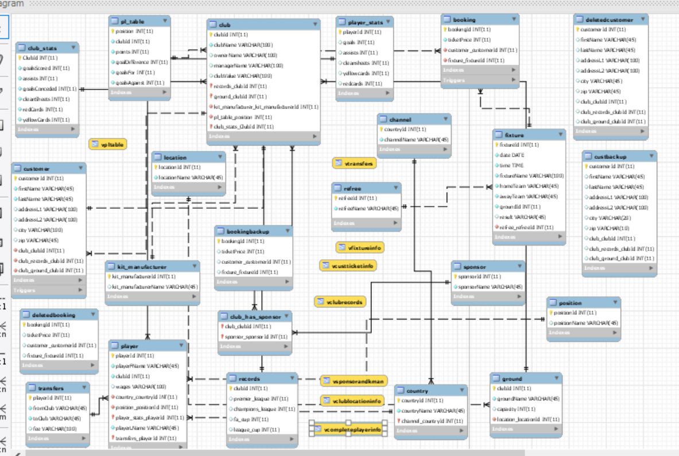

The EER diagram consist of 19 main tables and 4 backup tables. The main tables are customer booking fixtures which help in fixture management and booking tickets. The club and player tables help us retrieve information about different clubs, players and sponsors.

**VIEWS:**

1. The following view is used to display customer ticket information.

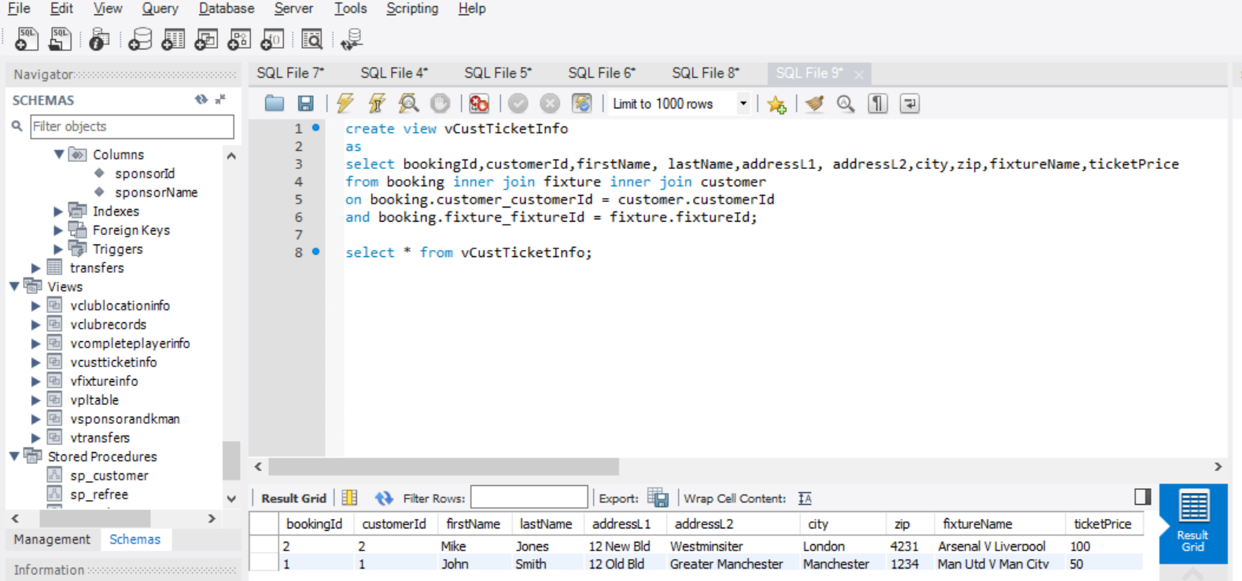

2)

This view is used to retrieve locations of different club grounds.

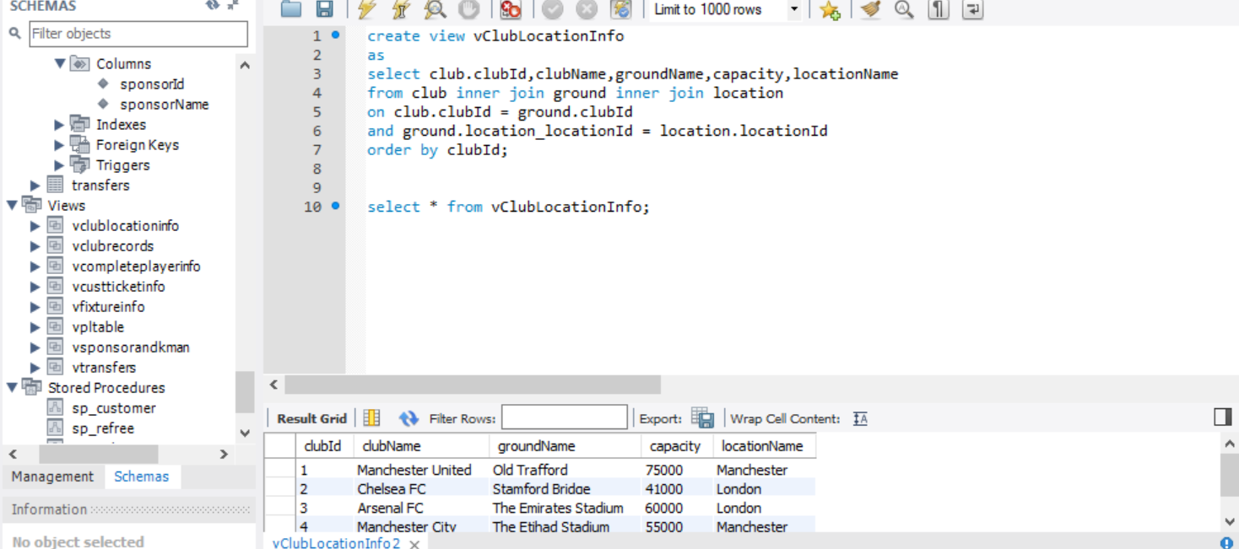

3)

This view is used to retrieve different sponsors and kit manufacturers of different clubs.

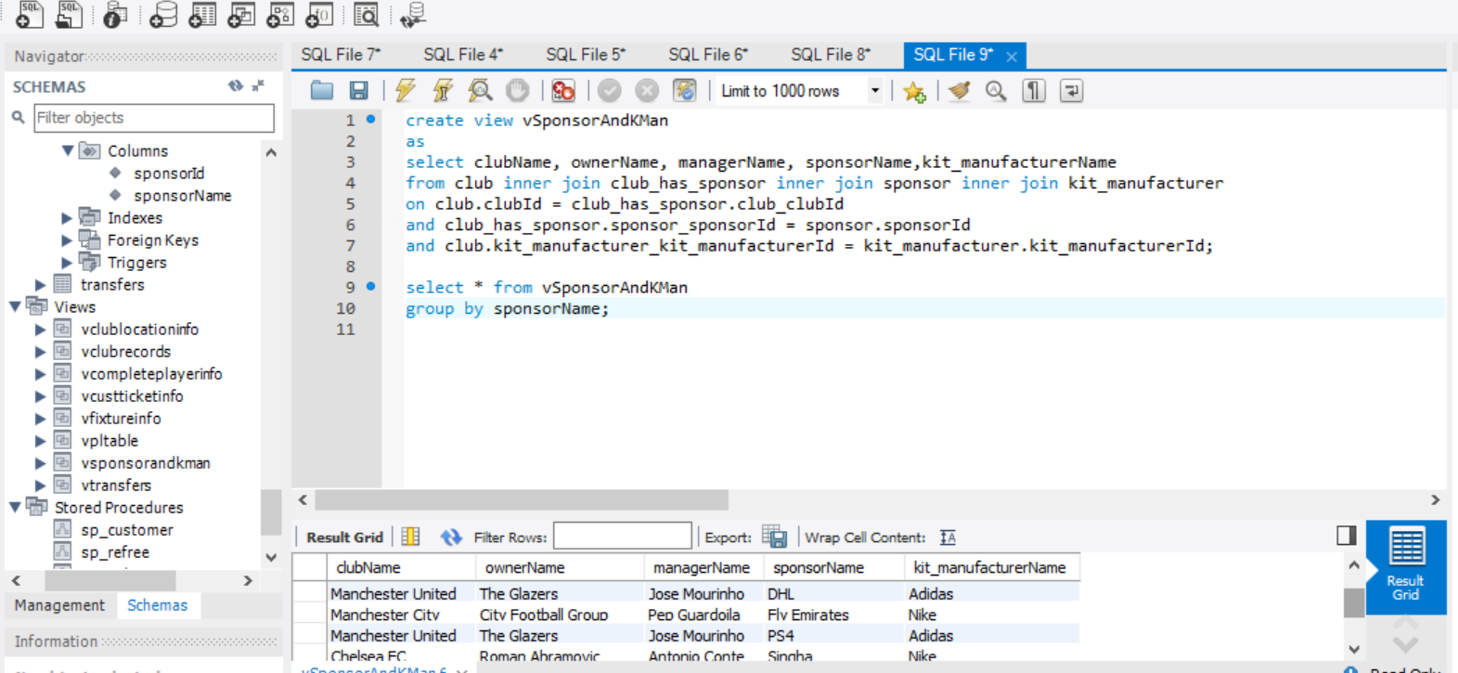

4)

This view is used to find complete information about a player.

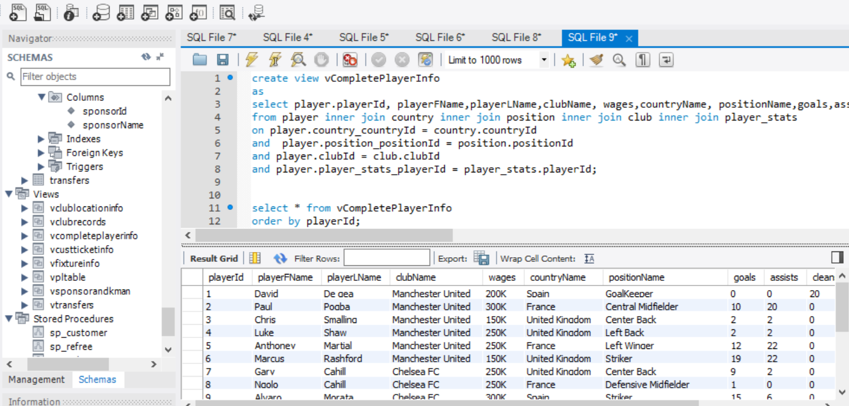

5)

This view is used to retrieve different information about player transfers between different clubs.

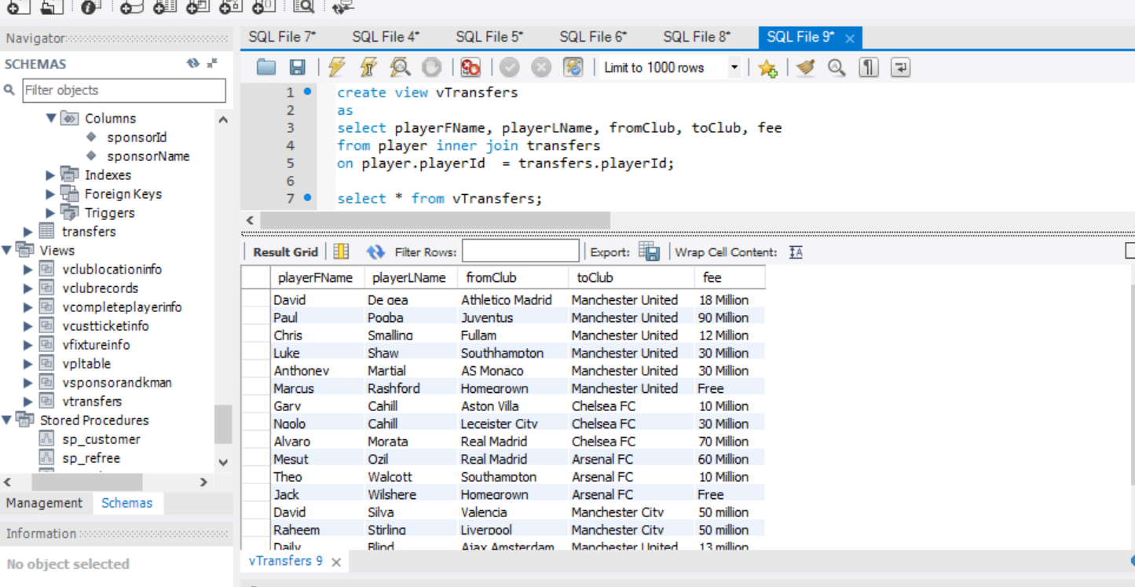

6)

This view is used to display the league table.

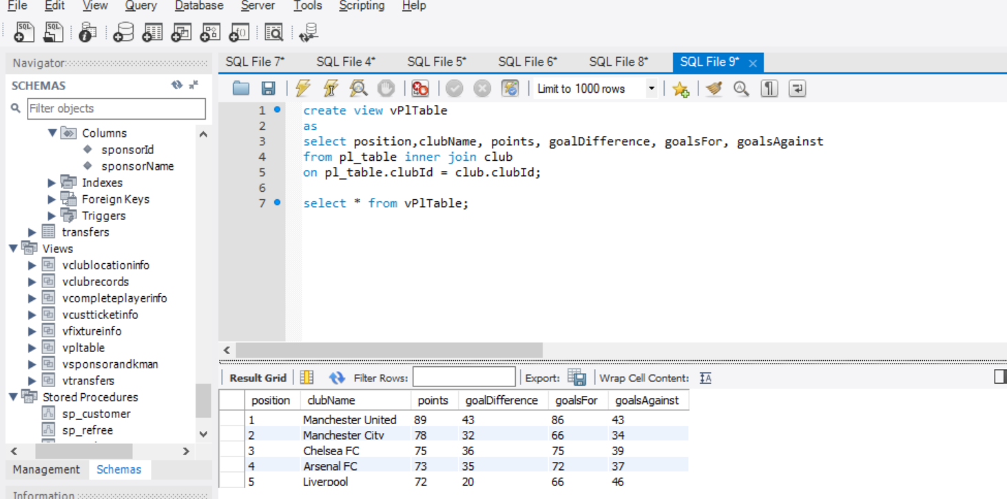

7)

This view is used to display the various achievements of different clubs.

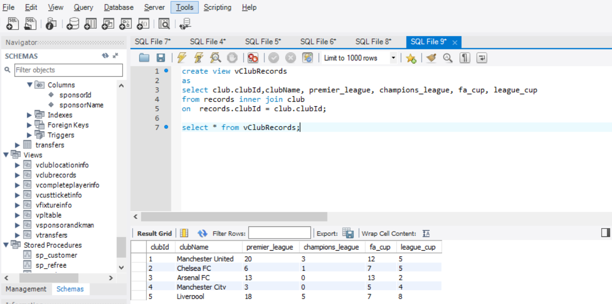

8)

This view is used to fetch the complete fixture information.

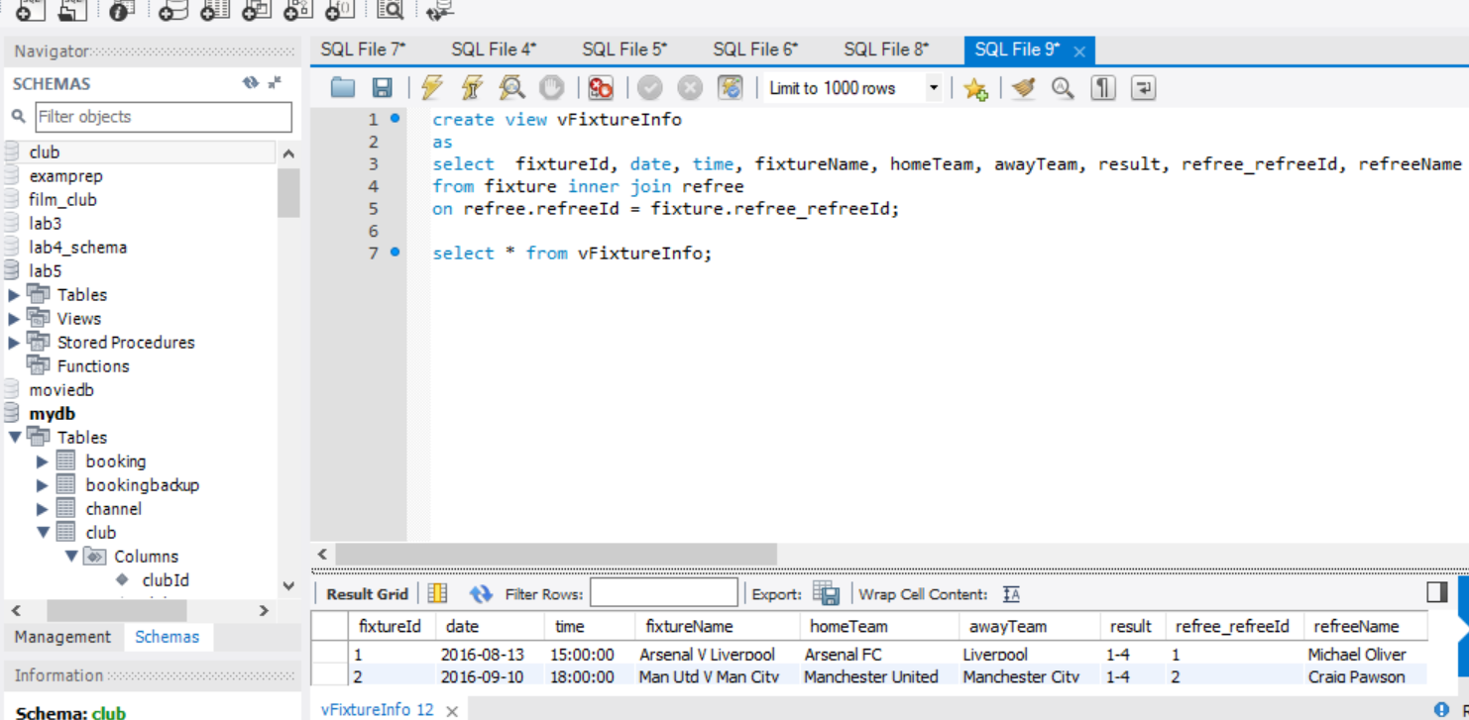

**STORED PROCEDURES:**

1)

This stored procedure is used to insert customer information in the customer table.

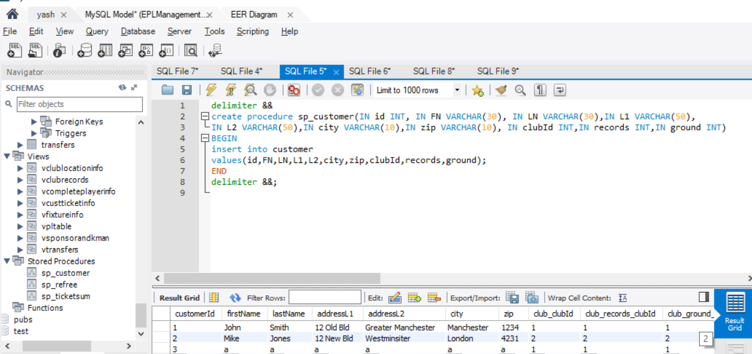

2)

This stored procedure is used to insert referee information in referee table.

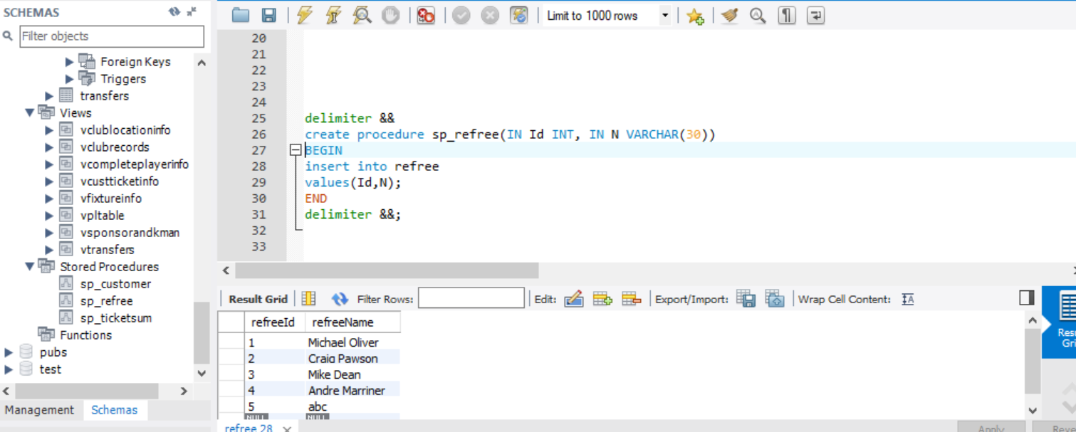

3)

This procedure is used to calculate the revenue from match ticket sales.

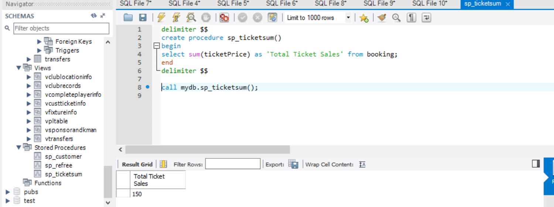

**TRIGGERS:**

1)

The following trigger is fired when any new record is inserted in the customer table and with the help of the trigger the same record is inserted in the customer backup table.

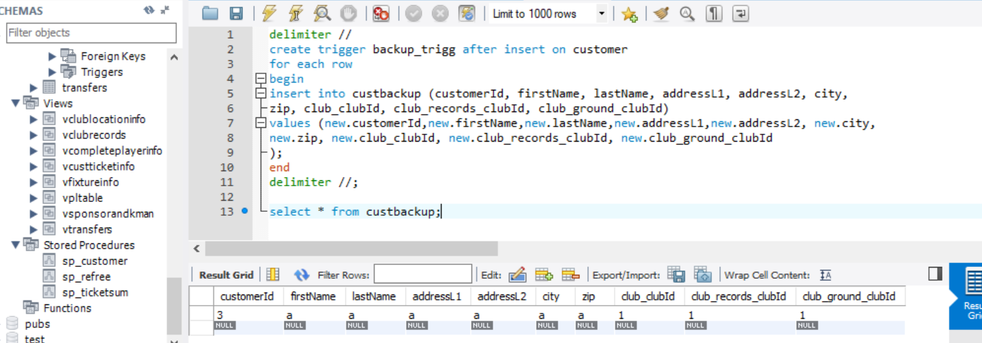

2)

The following trigger is fired when any new record is inserted in the booking table and with the help of the trigger the same record is inserted in the booking backup table.

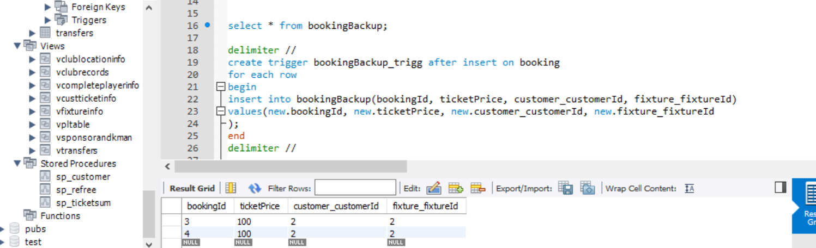

3)

This trigger is fired after a record is deleted from the customer table and with the help of the trigger the same record is inserted in the deleted customer table.

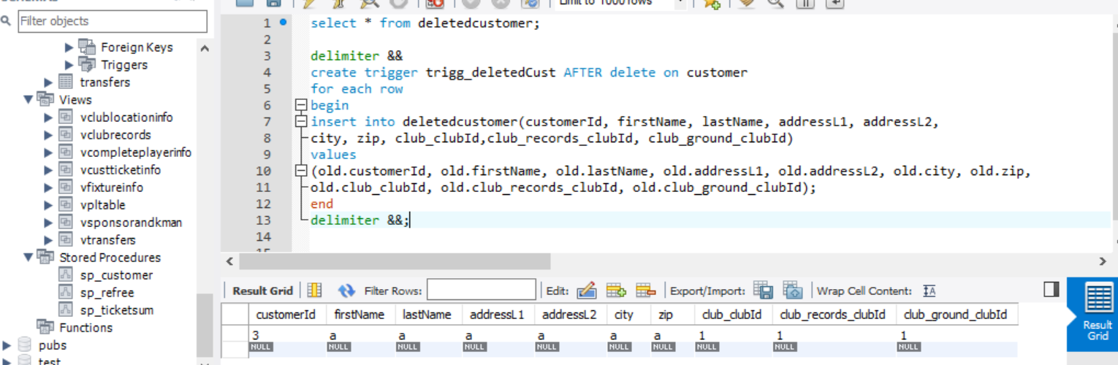

4)

This trigger is fired after a record is deleted from the booking table and with the help of the trigger the same record is inserted in the deleted booking table.

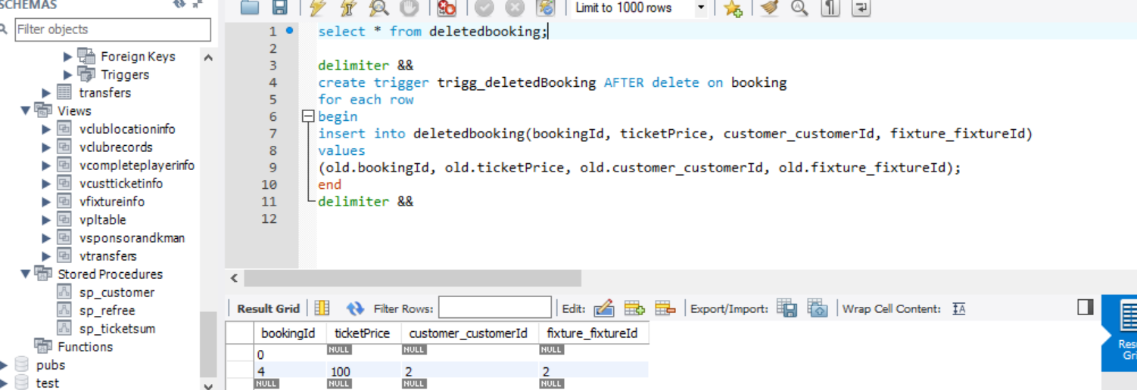

**PRIVILAGES:**

1)

A new user by the name of viewer has been created and has been assigned password as viewer.

A viewer can be any person who wants information stored in the database.

The viewer has privileges only to select various tables and views from the database.

